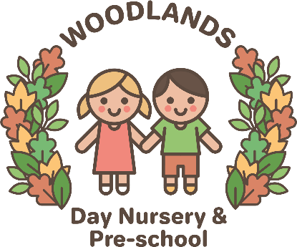
Communication Policy
Our belief:
At Woodlands Day Nursery & Preschool our aim is to ensure that communication is a priority through all members of school staff, children, parents and the wider community. Through effective and targeted communication, information is shared; understanding is developed; trust is built and learning is accessible to all.

What is Communication?
Communication is the ability to say the right thing, at the right time in the right way.
Communication is more than just the exchange of words. It involves giving and receiving messages, taking turns and reading non-verbal signs. Effective communication includes both the development of language (the ability to understand and use words and sentences) and speech (the ability to combine sounds to make words.)

Communication & Woodlands Day Nursery & Preschool Values:
- Be a good friend: good language will develop positive friendships and improve children’s social skills.
- children will be responsible for their own actions and behaviours. Children will feel more confident to ‘speak out’ and take responsibility for their own learning.
- Have Courage: children will be able to learn new words and use them appropriately.
- Trying your best: children will be willing to constantly strive to improve their vocabulary and take a more active part in their learning.
- Pride: children will be proud of their achievements and be able to express to others their pride in their language.
- Aspirations: children will aspire to improve their vocabulary and communicate effectively with others.
- Caring: children will consider the impact communication will have on others and its appropriateness.
- Thankfulness: children will have an appreciation of the language choices people are making and the time and opportunity to promote their communication skills.

Aims:
- Our aim is improve the communication skills of all children.
- To ensure through specialist and in-house training that all staff have the strategies, knowledge and confidence to continually develop speech and language in all aspects of school life.
- To screen all children on entry continually monitor the progress every 10 weeks.
- To provide specific interventions, in addition to quality first teaching, for pupil’s identified with specific speech, language and communication needs.
- To ensure the nursery uses skills cascaded through ELKLAN training
- All staff is aware of the importance of sharing good practice with other members of staff and parents.

Nursery Environment:
We ensure that the learning environment reflects and supports our aims to continually develop speech and language at Woodlands Day Nursery & Preschool.
The environment includes the following:
- Interaction and BLANK level question posters and prompts displayed and used in all of the learning spaces within the setting.
- Skills for good listening are displayed in all classrooms.
- Visual timetables used consistently where appropriate in the learning areas of the setting

Woodlands Day Nursery & Preschool Practice:
- All staff to be trained in Communication (ELKLAN, ECAT)
- All children screened on arrival and termly to assess progress
- Focused adult interactions and questioning is differentiated according to ELKLAN ability.
- All staff is aware of appropriate levels of questioning with children in the continuous provision. (BLANK)
- ECAT: children are screened using ECAT three times a year and ECAT objectives are clearly seen on planning.
- Children’s Voice / Interests are clearly adhered to and evident in display’s.

Assessment & Recording Arrangements:
- Staff SENCO observations of Speech, language and Communication needs.
- Standardised screening and assessment tools (TALC)
- Assessments by outside agencies, including Educational Psychology, Speech Therapy and Learning Support Service.
- Play Plan have specific, achievable targets and are reviewed frequently, in line with our assessment cycle

