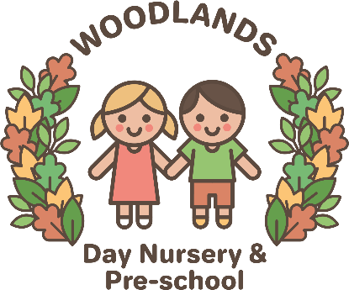

Exclusion Policy

There are certain occasions when it may be necessary to ask a parent to not bring their child to nursery for a short period of time. These reasons include:
- If a child is ill (see the Sickness and illness policy for more detailed information)
- If a child has a highly infectious condition e.g. impetigo, Conjunctivitis, Hand, foot and mouth, Oral Thrush and chicken pox
- If the child has a notifiable disease
- If a child has had a bout of sickness or diarrhoea within the last 48 hours.
- If a child is on antibiotics that they haven't taken before (in case of an allergic reaction)

The management of the nursery reserve the right to terminate a contract with immediate effect and exclude a child permanently if they:
- Continually demonstrates aggressive behaviour to the other children in the nursery
- Continually uses inappropriate language (swearing)
- Continually makes inappropriate remarks, such as racist comments
- Is likely to cause harm to other children in the setting
- Is found to be stealing from staff or the nursery

Nursery staff will already have discussed their concerns with you and worked with you over a period of time to address your child's behaviour. Nursery staff would have used a variety of different strategies and with parental permission sought support from outside agencies.

Exclusion of a child would only occur if their behaviour was very severe and having a continued negative impact on the other children in the nursery.

