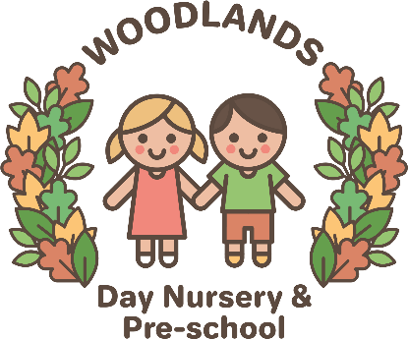
Health and Wellbeing Policy
‘To achieve their potential school children must participate fully in educational activities. To do this they must be healthy, attentive and emotionally secure.’ World Health Organisation (WHO) 2000.

Nursery Ethos
Woodlands Day Nursery & Preschools values and ethos; Kindness, Friendship, Responsibility, Aspirations, Pride, Courage, Trying Your Best, Making Good Choices, Caring and Thankfulness. are reflected in all our policies, the curriculum we deliver and all aspects of nursery life
We actively promote the support that can be provided by a range of agencies. Where appropriate, our SENCO may become involved to support a child experiencing emotional and behavioural difficulties. If required, staff are aware of the correct pathway to gain extra support to help children with specific needs.

Rationale
At Woodlands Day Nursery & Preschool we are taking a whole setting approach to Health and Well-being Education.

‘Health is the extent to which an individual or group is able, on one hand, to realise aspirations and satisfy needs and, on the other hand, to change or cope with the environment. Health is, therefore seen as a resource for everyday life, not an object of living; it is a positive concept emphasising social and personal resources, as well as physical capabilities.’ World Health Organisation (WHO) 2000.

The emotional health and well-being of Woodlands Day Nursery & Preschool is fundamental to our philosophy and aims. We believe that emotional health is closely linked to mental health and that as a setting we can encourage positive development of mental health in childhood. We believe that children who are mentally healthy;
- Develop psychologically, emotionally, creatively, intellectually and spiritually.
- Initiate, develop and sustain mutually satisfying personal relationships.
- Become aware of others and emphasise with them.
- Play and learn
- Develop a sense of right and wrong.
- Face challenges, resolve issues and setbacks and learn from them.

Our aim is that our children in our setting will develop the self-esteem, awareness and self-confidence to play an active part in nursery life and be valued and valuable members of their communities, now and throughout their lives.
CURRICULUM ORGANISATION
Staff use a variety of methods for ensuring sound emotional health and wellbeing for children. These compliments and reflect the overall aims and philosophy of Woodlands Day Nursery & Preschool. Our approach includes:
- Nurture groups
- Reinforcement of our setting values
- Clearly identified rewards and sanctions understood by all (age appropriate)
- Rewarding positive behaviour and achievement
- Setting appropriately challenging tasks
- Providing a forum for listening and turn taking
- Encouraging cooperation and collaboration
- Developing social competence
- Encouraging and developing coping strategies and resilience
- Leuven scales
- Boxall assessments
- Promoting British Values

We see parental involvement as a vital part of emotional wellbeing. Regular opportunities exist to promote partnership with parents, including:
- Parents evening twice a year
- 2 year old check
- Availability of staff and management each morning and evening for parents queries during morning and evening drop offs/pick ups
- Activities linked to the EYFS curriculum for family learning time
- Parent workshops
- Quarterly parental questionnaires, to help us build on what we do best and identify areas for improvement
- Monthly parent question
- Parents board
- Communitree
- Open days
- Children’s voice
- Promote activities within the community
Pastoral organisation of children
We pride ourselves on the great care that is given to all pupils in our setting. We use the following methods to provide the foundations for emotional health and well-being.
Our methods include:
- Recognising and responding positively to a child’s emotional and behavioural needs
- Communications with parents positively and realistically to create a partnership approach to children’s emotional health and wellbeing
- Liaising with appropriate agencies to enlist advice and or support
- Highly effective adult interactions
- Clear transition arrangements
- A highly effective behaviour and reward system
- Transition visits
- Nurture groups
- Assessment of children using Leuven scales and Boxall (where appropriate)
- Working with the Starting Life Well Team to gain information and training
- Close links with Salford Children’s Services

Pastoral organisation for Staff
We follow guidelines and policies for supporting personnel, including those from harassment, who may need counselling, anti-bullying, race equality and managing staff absence. A clear system of line management exists to monitor and support staff needs. Our line management structure promotes in house support. We also use outside agencies where needed to further assist in support.

