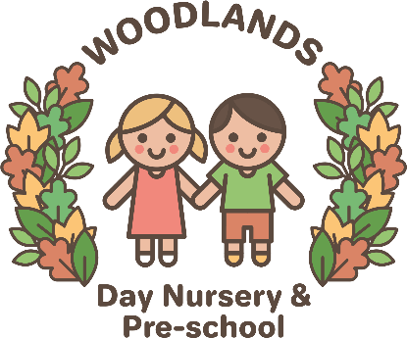
Healthy Workplace
Woodlands Day Nursery & Preschool, is committed to providing a workplace which supports and encourages a healthy staff team through sharing information, training and family friendly issues.
Dress code
Staff must follow our dress code at all times, which is given to new staff during induction and also contained with the company handbook.
Personal hygiene
Staff must follow the personal hygiene code below at all times, and encourage children to adopt the same good personal hygiene code themselves.
- All hands must be washed before handling food, after using the toilet or toileting children, after playing outside, wiping noses and after contact with animals.
- After noses have been wiped the tissue must be disposed of hygienically and hands should be washed.
Cleaning
Woodlands Day Nursery & Preschool is committed to providing a safe, happy and healthy environment for children to play, grow and learn. Cleanliness is a vital step to ensure this. The nursery will be cleaned every day and regular checks will be made in the bathrooms - these will be cleaned at least daily (more if necessary). The nappy changing facility will be cleaned after every use, and potties will be cleaned out after each use. Any mess caused throughout the day will be cleaned up as necessary to ensure that a hygienic environment is provided for the children in our care.
Kitchen
Kitchen Staff need to be aware of the basic food hygiene standards through appropriate training and this will be reviewed every three years.
- Fridges to be cleaned out weekly
- Microwave to be cleaned after each use
- Oven to be cleaned out regularly
- Freezers to be cleaned out every three months and recorded
- All cupboards to be cleaned out monthly
- Fridge and freezer temperatures must be recorded first thing in the morning by the duty manager/cook and in the afternoon
- All food to be covered at all times in and out of the fridge and dated to show when each product was opened
- Care must be taken to ensure that food is correctly stored in fridges
- When re-heating food it should over 75°C, checked with the probe thermometer and recorded, then cooled down before serving. Food prepared on the premises must be checked with the probe thermometer before serving
- Food served but not used immediately should be appropriately covered and placed in the fridge/freezer within 60 minutes. If this is not followed, food should be discarded immediately
- All opened packets to be dated when opened and placed in an airtight container e.g. baby food, raisins, cereal etc.
- Blended food should be placed in suitable airtight containers, named and dated • Surfaces to be cleaned with anti-bacterial spray
- Children must NOT enter the kitchen except for supervised cooking activities
- Doors/gates to the kitchen to be kept closed/locked at all times.
Baby room
- Bottles of formula milk will only be made up as and when the child needs them. These should be cooled to body temperature (37C) and tested to ensure they are an appropriate temperature for the child to drink safely
- Bottles will be disposed of after two hours
- Labelled mother’s breast milk will be stored in the fridge
- If dummies are used they will be cleaned and sterilised. This also applies to dummies which have been dropped
- Sterilisers will be washed out daily.

Nursery
- Staff must be aware of general hygiene in the nursery and ensure that high standards are kept at all times
- Toys are washed with sanitising fluid on a regular basis
- Floors should be cleaned during the day when necessary. Vacuum cleaner bags (where used) should be changed frequently
- Disposable face cloths are not shared between children
- High chairs must be cleaned thoroughly after each use. Straps and reins must be washed weekly or as required
- Each child should have its own cot sheet and bedding which should be washed at the end of each week or whenever necessary
- All surfaces should be kept clean and clutter free
- Children must always be reminded to wash their hands after using the bathroom and before meals. Staff should always encourage good hygiene standards, for example, not eating food that has fallen on the floor
- Children should learn about good hygiene routines and why they need to wash their hands, wipe their noses and cover their mouths when coughing.

