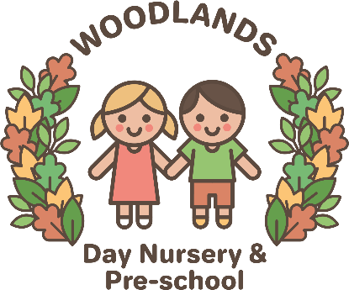
Out of School Care
Nutrition and Snack Time Policy
Here at The Woodlands out of school club we believe that snack time should be a happy and enjoyable time for children and adults and we encourage positive social interactions. We are committed to providing healthy, nutritious, balanced snacks which meet the individual needs of the children in our care.
We will:
- Provide nutritious food at snack times, avoiding too much fat, sugar and salt.
- Provide a variety of fresh fruit and vegetables
- Ensure that fresh drinking water is readily available for children to access independently
- Involve children (and parents if they want to) in the planning of snacks
- Encourage the children to be independent by letting them serve themselves
- Ensure that cultural diversity will be reflected in the food that we offer
- Respect individual dietary requirements. A list will be kept on the inside of the kitchen cupboard and referred to when planning snacks
- Ensure that we are aware of any allergies, this will also be kept on the inside of the kitchen cupboard, and take these into account when planning snacks. If necessary we will carry out a risk assessment for severe allergies in order to ensure the welfare of children in our care
- Encourage children to use their manners at snack time
- Never leave the children alone whilst they are eating
- Encourage children to try new foods, but not force them to eat anything they may not like and not force them to eat snack if they really do not want to
- Promote an understanding of healthy eating and why it is important.
Examples of the food we offer at snack time are as follows:
- Sandwich/wrap/pitta/roll filled with – Cream cheese, jam, marmite, ham, chicken, egg mayonnaise, tuna mayonnaise/ crackers with butter/malt loaf
- Fruit – apple, pear, melon, mango, orange, banana, grapes, apricot, plum, strawberry, peach.
- Salad – cucumber, tomato, celery, sweetcorn, pepper, carrot.
- We also offer cheese and either a sweet or savoury biscuit.
- We offer a selection of sandwiches and different fruit and salad each day, the children will not be offered all of these things every day. On special occasions or celebration days we will adapt our snack to suit this.

During holiday club, when children bring their own packed lunch, we encourage parents to send a nutritious, balanced lunch. If we have a child in the setting with a severe allergy we will ask parents not to send that product in with their own children, in case the allergic child comes into contact with it.

