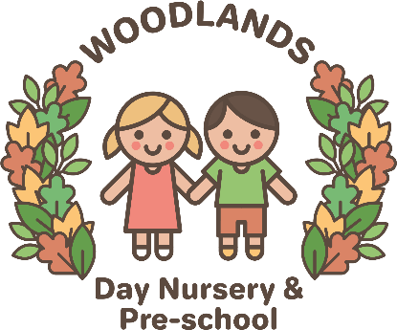
Nutrition and Mealtimes
Mealtimes should be a happy, social occasion for children and staff alike. Positive interactions should be shared at these times and enjoyed. The Woodlands Day Nursery & Preschool is committed to offering children healthy, nutritious and balanced meals and snacks which meet individual needs and requirements.
We will ensure that:
- Balanced and healthy midday meal, tea and daily snacks are provided for children attending a full day at the nursery
- Menus are planned in advance, rotated regularly and reflect cultural diversity and variation. These are displayed for children and parent/carer(s) to view
- We provide nutritious food at all snack and meal times, avoiding large quantities of fat, sugar and salt and artificial additives, preservatives and colourings
- Parent/carer(s) and children are involved in menu planning via our parent questionnaire and feedback.
- Fresh drinking water is constantly available and accessible. It is frequently offered to children and babies.
- Individual dietary requirements are respected. We gather information from parent/carer(s) regarding their children’s dietary needs including any special dietary requirements, preferences and food allergies that a child has and any special health requirements before a child is admitted to the nursery. Where appropriate we will carry out a risk assessment in the case of allergies and work alongside parent/carer(s) to put into place an individual dietary plan for their child
- Staff show sensitivity in providing for children’s diets and allergies. They do not use a child’s diet or allergy as a label for the child, or make a child feel singled out because of her/his diet or allergy
- Meal and snack times are organised so that they are social occasions in which children and staff participate in small groups. During meals and snack times children are encouraged to use their manners and say 'please' and 'thank you' and conversation is encouraged
- Staff use meal and snack times to help children to develop independence through making choices, serving food and drink, and feeding themselves.
- We provide foods from the diet of each of the children’s cultural backgrounds, providing children with familiar foods and introducing them to new ones. Cultural differences in eating habits are respected
- Children are given time to eat at their own pace and not rushed
- Quantities offered take account of the ages of the children being catered for
- We promote positive attitudes to healthy eating through play opportunities and discussions
- The nursery provides parent/carer(s) with daily records of feeding routines for all children under 3 or until they move into pre-school.
- No child is ever left alone when eating/drinking to minimise the risk of choking All staff that prepare and handle food are competent to do so and receive training in food hygiene.

