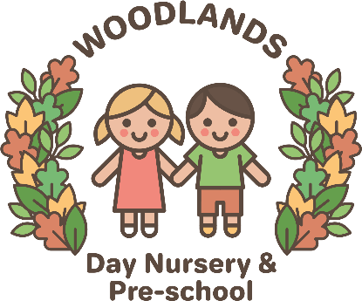
Waste Management
Staff are made aware of the need to minimise energy waste and the nursery uses appropriate measures to save energy, including:
- Energy saving light bulbs
- Turning off lights when not in use
- Sensor lights
- Not leaving any equipment on standby
- Energy saving wash cycles on the washing machine.
The nursery recycles paper, tin cans and plastic via a recyclables bin which is collected once a fortnight. We assess our nursery’s impact on the environment on a regular basis and place procedures in place to counteract this impact.
This policy is reviewed annually and is carefully considered in the best interests of the children, nursery and the environment.
Disposal of Bodily Waste Procedure
To minimise the risk of infection we ensure that:
- All staff wear disposable gloves and aprons when toileting/nappy changing children.
- Soiled nappies, wipes and used gloves etc are placed in nappy sacks and disposed of in the nappy bin.
- Bodily fluid eg vomit, blood is cleaned by disposable paper towels and placed in a bag in the nappy bin or in the outside bin. If cloths or rags are used to clean up, these are disposed of in the same way.
- Changing mats are cleaned after every use with disposable paper towels and anti-bacterial spray and hands washed thoroughly.
- Any soiled clothes are placed in a nappy bag.
At Woodlands Day Nursery & Preschool we value our environment and in order to keep our earth safe and healthy for our children we closely monitor the management of our waste and its disposal in accordance with local authority requirements.

